DSP- 2 Marks questions with answers
UNIT-1
1.Define Signal.
A Signal is defined as any physical quantity that varies with time, space or any other independent variables. A signal can also be defined as a physical quantity which can be represented as a function of one or more variables which carries information.
2. Define system.
A System is a physical device (i.e., hardware) or algorithm (i.e., software) that performs an operation on the signal.
3. What are the steps involved in digital signal processing?
- Converting the analog signal to digital signal, this is performed by A/D converter
- Processing Digital signal by digital system.
- Converting the digital signal to analog signal, this is performed by D/A converter.
4.Give some applications of DSP?
• Speech processing – Speech compression & decompression for voice storage system
• Communication – Elimination of noise by filtering and echo cancellation.
• Bio-Medical – Spectrum analysis of ECG,EEG etc.
• Process Industries- signal conditioning circuits in sensors and transducers
5. Define discrete-time system.
A system that processes a discrete-time input signal and produces a discrete-time output signal.
6. Write the Various classifications of Discrete-Time systems.
• Linear & Non linear system
• Causal & Non Causal system
• Stable & Unstable system
• Static & Dynamic systems
• Time variant & Time invariant systems
• Recursive & Non Recursive systems
• FIR & IIR systems
7.Define Z transform.
The Z transform of a discrete time signal x(n) is denoted by X(z) and is given by
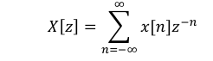
8. List any four properties of Z-Transform.
- Linearity
- Time Shifting
- Frequency shift or Frequency translation
- Time reversal
9. What is BIBO stability?
A system is stable if every bounded input produces a bounded output.
Condition:
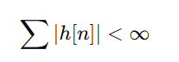
10. What is ROC in Z-Transform?
The values of z for which z – transform converges is called region of convergence (ROC). The z-transform has an infinite power series; hence it is necessary to mention the ROC along with z- transform.

UNIT-2
1. Define DFT.
The Discrete Fourier Transform (DFT) converts a finite-length discrete signal from time domain to frequency domain.
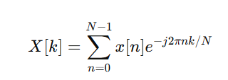
2. Define IDFT.
IDFT converts the frequency-domain sequence back to the time-domain:
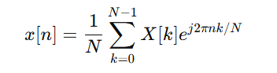
3. What is the twiddle factor?
A complex rotation constant used in DFT/FFT:
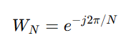
4. List the properties of DFT.
Linearity, Periodicity, Circular symmetry, symmetry, Time shift, Frequency shift, complex conjugate, convolution, correlation and Parseval‘s theorem.

5. Define circular convolution.
Circular convolution is convolution where the sequence wraps around after N samples:
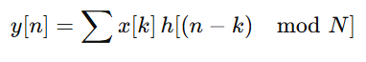
6. State Parseval’s Theorem for DFT.
Total energy in time domain equals energy in frequency domain:
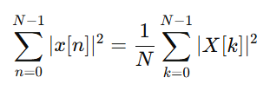
7. What is the way to reduce number of arithmetic operations during DFT computation?
Number of arithmetic operations involved in the computation of DFT is greatly reduced by using different FFT algorithms as follows.
Radix-2 FFT algorithms. - Radix-2 Decimation in Time (DIT) algorithm. Radix-2 Decimation in Frequency (DIF) algorithm. Radix-4 FFT algorithm.
8. What are the differences and similarities between DIF and DIT algorithms?
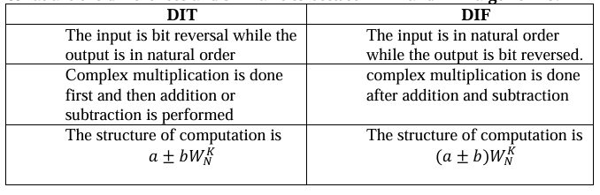
9. Calculate the number of multiplications needed in the calculation of DFT using FFT algorithm with using FFT algorithm with 32-point sequence.
For N-point DFT the number of complex multiplications needed using FFT algorithm is N/2 log2N. For N=32, the number of the complex multiplications is equal to 32/2log232=16*5=80.

9. What is zero-padding?
Adding zeros to the signal.
Uses:
- Increase frequency resolution
- Perform linear convolution using DFT
UNIT-3
1.Define IIR filter.
An IIR (Infinite Impulse Response) filter has an impulse response that extends indefinitely because it uses feedback.
2. What is a Butterworth filter?
A Butterworth filter is an analog filter that has a maximally flat magnitude response in the passband.
This means:
- No ripples in the passband
- Smooth, monotonic response
- The gain decreases gradually and smoothly as frequency increases
3. What are the various methods to design IIR filters?
• Approximation of derivatives
• Impulse invariance
• Bilinear transformation.
4. What is a Chebyshev filter?
A Chebyshev filter has ripples in the passband but provides sharper cutoff compared to Butterworth.
5. What is impulse invariant transformation?
The transformation of analog filter to digital filter without modifying the impulse response of the filter is called impulse invariant transformation.
6. What is bilinear transformation?
Bilinear transformation is a method to convert an analog filter into a digital filter. It maps the s-plane (analog) to the z-plane (digital) using the formula:
$$s=\frac{2}{T}⋅\frac{1-z^{-1}}{1+z^{-1}}$$
7. What is pre-warping?
Pre-warping is the method of introducing nonlinearly in frequency relationship to compensate warping effect.
8. What is Direct Form-I realization?
Direct Form–I is a structure used to implement IIR filters where the system is realized using two sections:
- Feedforward part (using input samples)
- Feedback part (using past output samples)
9. What is direct-form II structure?
Direct Form–II is an efficient IIR filter realization that uses only one delay line, instead of two.
It reduces the number of delay elements by combining input and output delay lines into a single set of delays.
10. What is cascade realization?
In cascade realization, the transfer function $H(z)$is factored into second-order or first-order sections, and each section is connected in series:
$$H(z)=H_{1}(z)H_{2}(z)H_{3}(z)$$
UNIT-4
1. What are the different types of filters based on impulse response?
Based on impulse response the filters are of two types
i) IIR filter ii) FIR filter
The IIR filters are of recursive type, whereby the present output sample depends on the present input, past input samples and output samples. The FIR filters are of non recursive type, whereby the present output sample depends on the present input and previous output samples.
2.What are the advantages of FIR filters?
- Linear phase FIR filter can be easily designed.
- Efficient realization of FIR filter exist as both recursive and nonrecursive structures
- FIR filters realized non recursively are always stable.
- The roundoff noise can be made small in nonrecursive realization of FIR filters.
3. What are the disadvantages of FIR filters?
- The duration of impulse response should be large to realize sharp cutoff filters.
- The non-integral delay can lead to problems in some signal processing applications.
4. What is the necessary and sufficient condition for the linear phase characteristic of an FIR filter?
The necessary and sufficient condition for the linear phase characteristic of an FIR filter is that the phase function should be a linear function of w, which in turn requires constant phase and group delay.
5. What are the possible types of impulse response for linear phase FIR filters?
There are four types of impulse response for linear phase FIR filters
• Symmetric impulse response when N is odd.
• Symmetric impulse response when N is even.
• Antisymmetric impulse response when N is odd.
• Antisymmetric impulse response when N is even.
6. What is Gibb’s phenomenon (or Gibb’s Oscillation)?
In FIR filter design by Fourier series method the infinite duration impulse response is truncated to finite duration impulse response. The abrupt truncation of impulse response introduces oscillations in the pass band and stop band. This effect is known as Gibb‘s phenomenon (or Gibb‘s Oscillation).
7. What is windowing technique?
Multiplying ideal impulse response with a window function to obtain a realizable FIR filter.
8. What is rectangular window?
A simple window where
$$w(n)=10≤n≤N-1$$
It has narrow main-lobe but high side-lobe.
9. What is Hamming window?
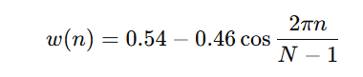
Used to reduce spectral leakage.
10. What is Blackman window?
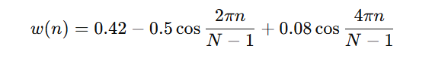
Gives high stopband attenuation.
UNIT-5
1.What is a Programmable DSP?
A Programmable DSP is a processor optimized for fast arithmetic and signal processing tasks, which can execute user-defined programs for real-time applications.
2.List two main features of TMS320C5X.
i) Fixed-point architecture ii) On-chip memory and peripherals for high-speed processing.
3. What is the role of Central ALU in TMS320C5X?
The Central ALU performs arithmetic (add, subtract, multiply) and logical (AND, OR, XOR) operations required for DSP algorithms.
4.What is an Auxiliary Register ALU (AR-ALU)?
It assists the main ALU by performing parallel address calculations and other operations to improve throughput.
5. What is the function of Parallel Logic Unit (PLU)?
PLU executes logical operations and comparisons in parallel with ALU, increasing overall processing speed.
6. Define memory-mapped registers.
Registers accessible via memory address space, allowing the CPU to communicate with peripherals as if accessing memory.
7. Name some flags in TMS320C5X status register.
Carry flag (C), Zero flag (Z), Overflow flag (O), and Interrupt Enable flag (IE).
8. What is on-chip memory?
Memory integrated into the DSP chip used for fast storage of program instructions and data.
9. Give examples of on-chip peripherals in TMS320C5X.
Timers, serial ports (UART) and GPIO for input/output operations.
10. Why is pipelining used in DSPs?
Pipelining overlaps instruction fetch, decode, and execution stages to improve throughput and performance.
Prepared by | Verified by | Check & Distribution of BL | Quality checked by
Mrs.Ch.Padmavathi  Assistant Professor  ECE  NECN | Mr.V.Sudheer  Assistant Professor-ECE  NECG | HoD-ECE NECG  HoD-ECE NECN | Principal NECG  Principal NECN

